How Razor Clam Seasons are Set
Washington State has actively managed the coastal recreational razor clam fishery since 1929. Over the decades there have been many changes as more and more people continue to move to the state and discover how enjoyable participation in the fishery is. The flow chart below details the many changes fishery managers have made to address increased digging pressure.
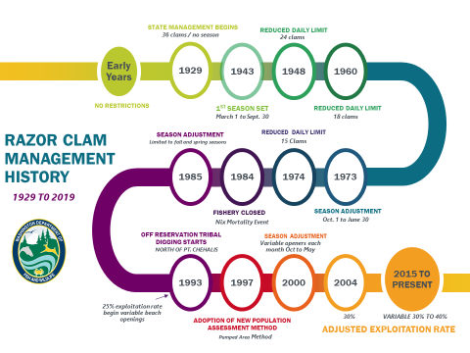
Today, the season setting process starts with a very detailed summer population assessment of each beach. A good description of how WDFW conducts this work can be found in the WDFW video available at this link ( https://www.youtube.com/watch?v=aC4fu6_8G8I ) After this population assessment is completed, the data collected is used to make estimates of total number of clams under 3 inches (pre-recruits) and total number of clams over 3 inches (recruits). These estimates are made for each of five management beaches (https://wdfw.wa.gov/fishing/shellfishing-regulations/razor-clams#beachmaps )
For each management beach, a Total Allowable Catch (TAC) is then calculated using a harvest rate that is applied to the estimate of recruit sized clams. The harvest rate used ranges between 30% and 40% depending on the overall strength of the population. The stronger the population, the higher the variable harvest rate and the weaker the population the lower the variable harvest rate. (The only exception is on the Kalaloch management beach where the TAC is fixed at 25.4%.)
On the three management beaches north of the mouth of Grays Harbor (Copalis, Mocrocks and Kalaloch) WDFW co-manages the razor clam resource with coastal tribes that have fishing rights in their usual and accustomed area (U&A). These include the Quinault Indian Nation which has fishing rights in the area that includes Copalis, Mocrocks and Kalaloch management beaches and the Hoh Tribe and the Quileute Tribe with fishing rights in the area that includes Kalaloch.
After the population assessment on these co-managed beaches is completed (by biologists and technicians from the state and the tribes working together), the TAC is calculated (in the same manner as we described above) with 50% then provided for the state fishery and 50% provided for tribal fisheries.
After the TAC’s have been finalized, WDFW begins to set state recreational razor clam openers in such a way to avoid exceeding the TAC or the state’s share of the TAC. In general, WDFW tries to provide openers each month (between October and May), while reserving clams for the months ahead. Obviously weather and surf conditions can cause great variations in the number of clams harvested on any specific day. However, should bad weather result in fewer clams being harvested, those clams remain a part of the TAC that will be used to set future openers.
When selecting days for harvest, WDFW always first considers the best low tides that fall around weekends. This is the time when the majority of harvesters can participate. When possible, week days with good low tides are also scheduled. Along the Washington coast, the best low tides (when digging success is optimized) always occurs during afternoon/evening (PM) hours in the fall and winter (between October and mid-March) and during morning (AM) tides in the spring (after mid-March.)
Only after the WDFW Director has approved the harvest dates and the Washington Department of Health Department analysis for marine toxins (from recent razor clam samples provided by WDFW) show clams are safe to each, then does WDFW announce that the upcoming harvest dates can proceed. That’s why it is important for harvesters to check our web site (https://wdfw.wa.gov/fishing/shellfishing-regulations/razor-clams#current ) before heading out to harvest razor clams.
In the end, the evidence is clear - a conservative management strategy allows razor clam populations to remain strong, allowing WDFW the flexibility to provide more harvest opportunities and more economic benefit to coastal economies.

